**CSC8502 Advanced Graphics for Games**

[**https://youtu.be/dh0CFeyGFhA**](https://youtu.be/dh0CFeyGFhA)

**Controls**

**O** - Toggles automatic camera movement

**P** - Toggles manual camera movement

**B** - Increases blur + shake post processing effect strength

**N** - Reduces blur + shake post processing effect strength

**Implemented features**

* **The scene must include a landscape of some form, rendered such that at least one texture is used in the fragment shader.**

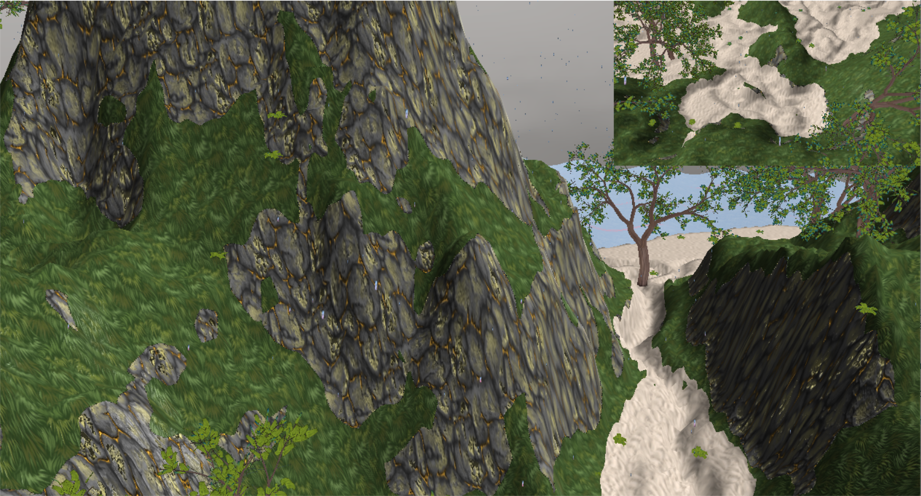

The scene features an island landscape with textures for rock, sand, and grass terrains.

* **Part of the scene must be lit using at least one light source, including calculations for ambient, diffuse and specular components.**

The terrain is lit by a single light source and the shader includes calculations for ambient, diffuse and specular lighting.

* **Part of the scene must show use of environment mapping.**

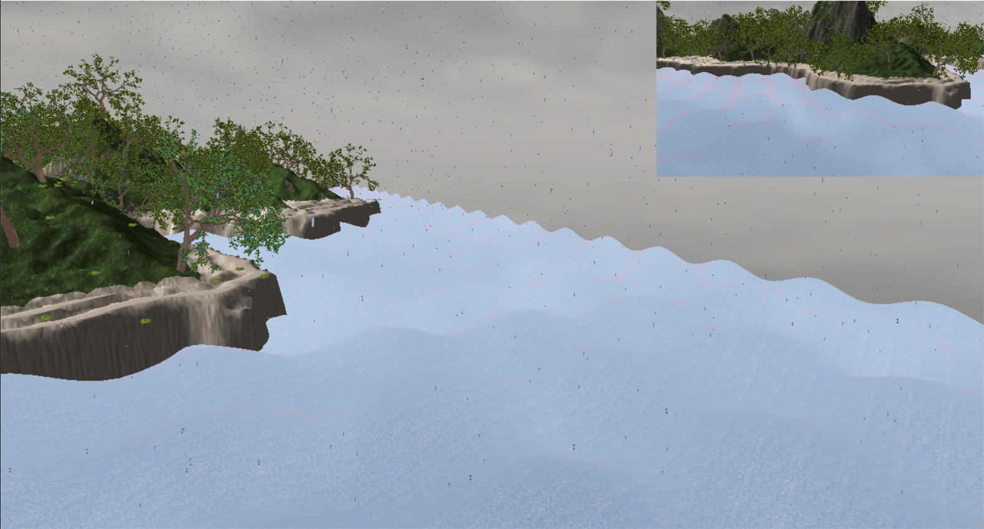

The scene includes a skybox which is also reflected by the water.

* **The camera should initially move automatically through the scene.**

When the scene starts, the camera starts automatically circling the island.

* **The scene should be controlled via an overall scene graph for efficient rendering.**

Everything in the scene is derived from the SceneNode class and are added to a single root node for efficient rendering.

* **Appropriate usage of simple meshes and textures to combine into additional scene elements.**

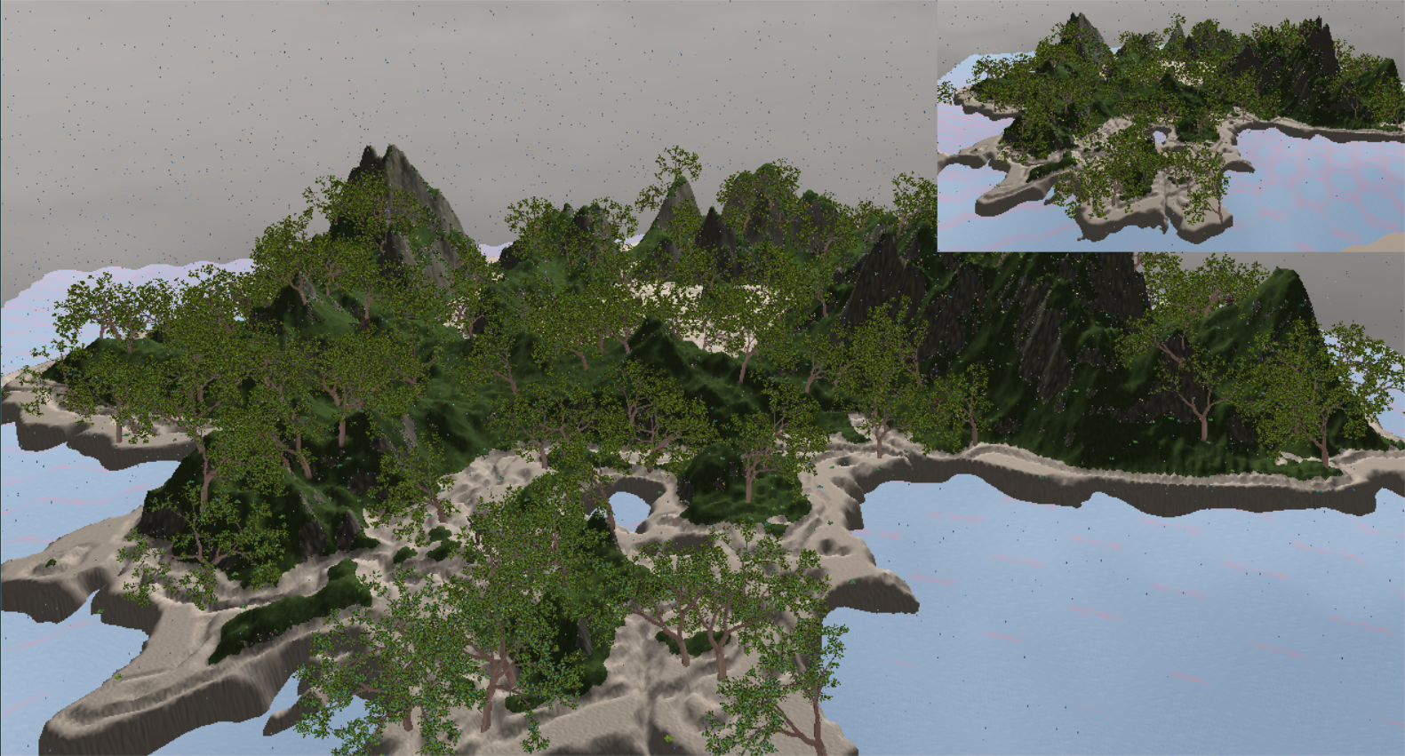

The scene includes vegetation such as trees and ferns.

* **Post processing effects: Blurring, colour correction, lens flare, HDR bloom effects etc. These may be applied to specific parts of the camera track, or optionally via keypresses.**

Blurring and screen shaking effects were implemented and are applied to the scene using the control buttons.

* **Advanced Lighting: Inclusion of new light calculations such as spot lights, projective lighting, or alternate methods of calculating the contribution of a large number of lights.**

No real-time shadow calculations were implemented in the scene.

* **Multiple viewpoints simultaneously using a split screen effect.**

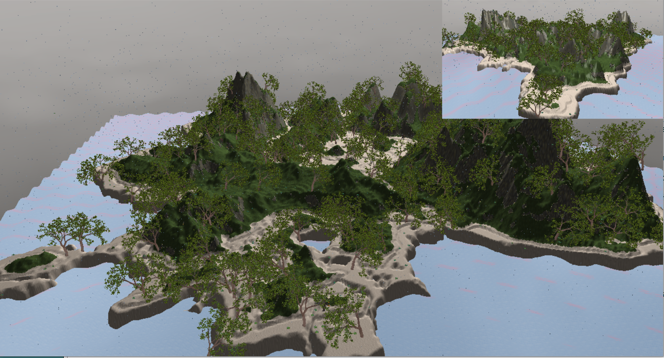

The scene includes two viewpoints being rendered.

* **Animated objects (skeletal animation, a progressively evolving tree mesh, grass waving in the wind).**

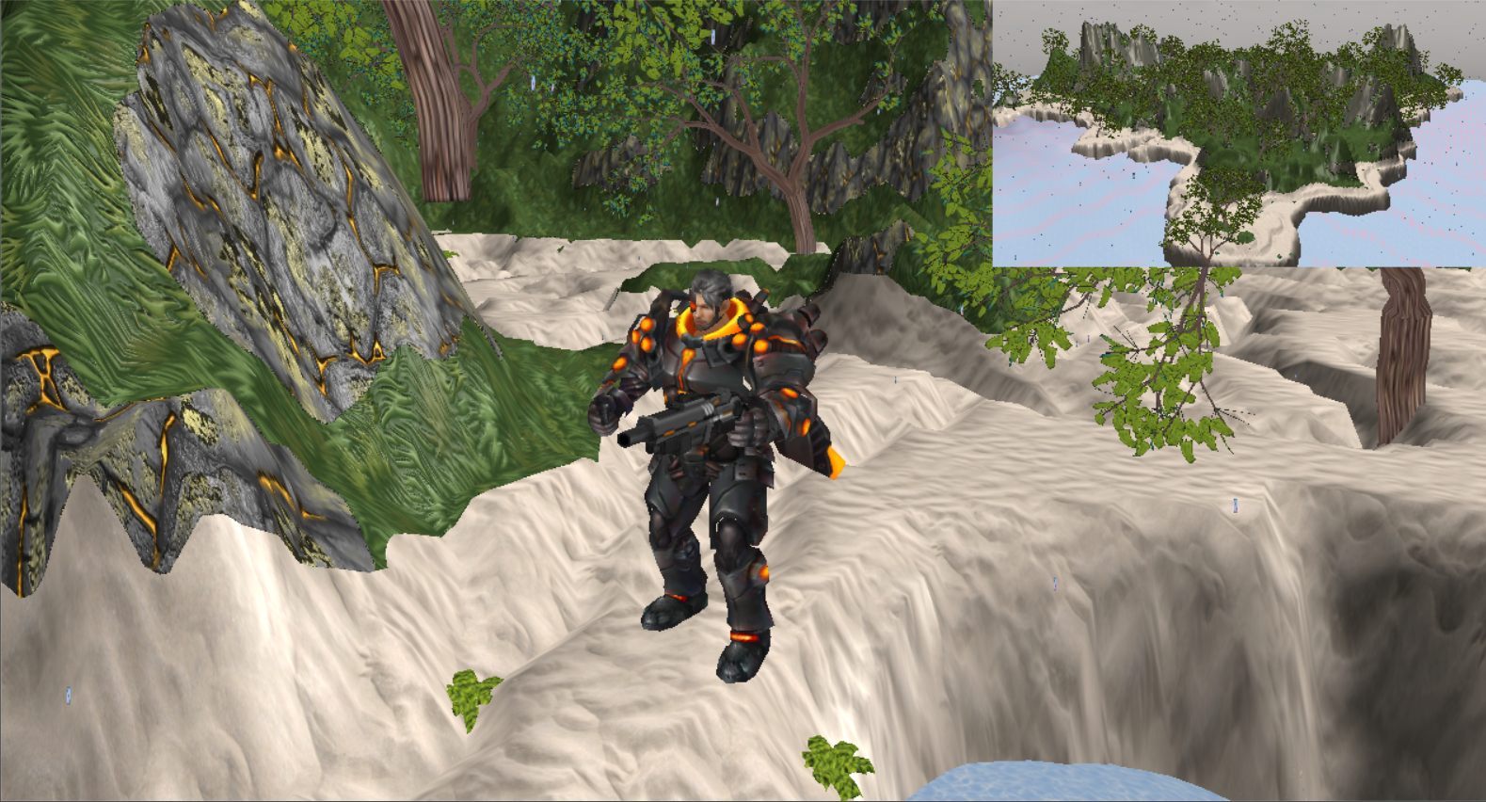

Animated models are randomly scattered throughout the scene.

* Environmental effects such as rain, splashing puddles, lightning strikes, or fire.

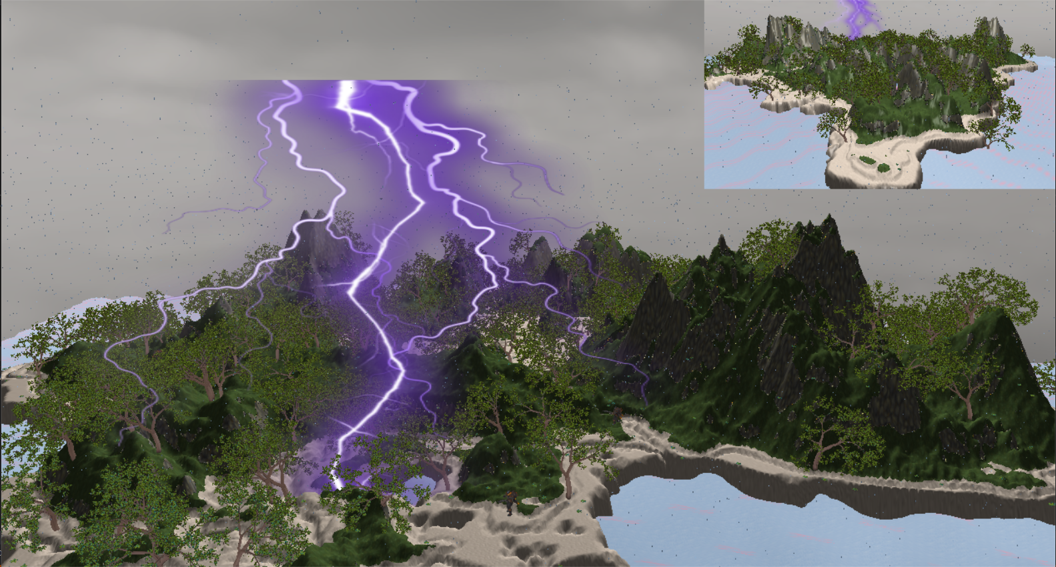

The scene includes rain and lightning strike effects.